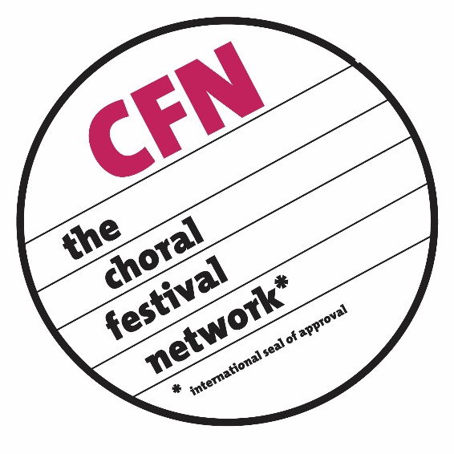

CFN - The Choral Festival Network
“the international network for
choral competitions and festivals”

Application for Admission

For application to The Choral Festival Network, please be so kind to complete this application.

Name of the festival/competition in native language:
Click here to enter text

Name of the festival/competition in English:
Click here to enter text

Address of the office:
Street & No. / Letterbox: Click here to enter street , number / letterbox
Town or City: Click here to enter town or city
Country: Click here to enter country
Postal Code: Click here to enter postal code
International country-code (2 letter country code): Click here to enter country code
Phone - office (including country code): Click here to enter number
Phone – mobile (including country code): Click here to enter number
Best time to call (in your country’s time): Click here to enter time
Telefax - office (including country code): Click here to enter number
Email address: Click here to enter email address
Other email address: Click here to enter email address
Website address: Click here to enter website link / address
Billing address (if different than above): Click here to enter address
Invoice recipient name: Click here to enter name
Invoice recipient email address: Click here to enter email

Festival Cycle: Select one

Financial supporting organization(s) (check all that apply):
If other, please explain: Click here to enter text

Type of organization: Select one

Type of choral event: Select one

If other, please explain: Click here to enter text

Year of foundation: Click here to enter year

Affiliations to national or international choral organizations:
Click here to enter text.
Click here to enter text.
Click here to enter text.
Click here to enter text.
Click here to enter text.

Director:
Family (Last) name: Click here to enter Family (Last) name
Given (First) name: Click here to enter Given (First) name
Title: Click here to enter title

Manager / Secretary General:
Family (Last) name: Click here to enter Family (Last) name
Given (First) name: Click here to enter Given (First) name
Title: Click here to enter title

Goals of the event: (please give a short description of festival goals, highlights, features, performances, etc.) Click here to enter text

Expenses for the participant: (please indicate currency)

Application fee?
per person per choir

Participation fee?
per person per choir

Fee for food?
per person per choir

Fee for accommodation?
per person per choir

Flat fee?
per person per choir

Please explain flat fee or any other fees not listed above:
Click here to enter text

Do participants / choirs have to pay their travel expenses? Select one
If partly, please explain: Click here to enter text

Participants’ remuneration/compensation:

Do participants receive a performing fee? Select one
(this information will not be published)

If yes, is it: Select one

How much? Select one

Catering (please describe conditions):
Click here to enter text

Statistics (please give some information on the last two editions of your event):

Last festival / competition:
Year: Click here to enter year
Number of participants: Click here to enter number of participants
Number of choirs: Click here to enter number of choirs
From (please indicate countries): Click here to list countries
Number of jury members: Select one
From (please indicate countries): Click here to enter countries
Number of prizes awarded: Click here to enter prizes awarded
Total prize amount (sum): Click here to enter amount

If you are doing workshops and training (last festival / competition only):
Number of choirs: Click here to enter number of choirs
Number of countries: Click here to enter number of countries
Number of lecturers: Click here to enter number of lecturers
Number of countries: Click here to enter number of countries
Working language(s): Click here to enter working language(s)

Information on concerts (last festival / competition only):
Number of concerts: Click here to enter number of concerts
Entrance/Admission fees: Click here to enter fees

Festival / competition before the last:
Year: Click here to enter year
Number of participants: Click here to enter number of participants
Number of choirs: Click here to enter number of choirs
From (please indicate countries): Click here to enter countries
Number of jury members: Select one
From (please indicate countries): Click here to enter countries
Number of prizes awarded: Click here to enter prizes awarded
Total prize amount (sum): Click here to enter countries

If you are doing workshops and training (festival / competition before the last):
Number of choirs: Click here to enter number of choirs
Number of countries: Click here to enter number of countries
Number of lecturers: Click here to enter number of lecturers
Number of countries: Click here to enter number of countries
Working language(s): Click here to enter working language(s)

Can we find the following information on your website? (please check all that apply):

☐ Competition rules/regulations
☐ Application forms
☐ Price list/fee list
☐ Accommodation/catering information
☐ Programs from previous festivals/competitions

By submitting this application, I hereby agree to the following terms and conditions (all items must be checked to proceed in the application process):

☐ The information in this application will be passed to the “Committee of Experts” of CFN.
☐ To allow my website information to be published on the CFN webpage.
☐ Upon request, to provide all information necessary for the CFN website and database.
☐ I accept the QUALITY GUIDELINES and will act according to them.
☐ I will provide guest status to one of the members of the “Committee of Experts” of the
CFN, upon request.
☐ To pay the membership fee during the first month of the year in order to keep my
membership status current.

Name of person submitting application: Click here to enter name
Title: Click here to enter title
Date: Click here to enter date

To submit this application:
- Save the application as a word document or a .pdf document.
- Attach the word or .pdf document to an email.
- Send the email to: info@choralfestivalnetwork.org

